**QNQ FRANCHISE**

**ABSTRACT**

* A Pharma QnQ franchise is a business model in which a pharmaceutical company grants a license to another party to sell its products and services in a designated area.
* In this model, the franchisee is accountable for the marketing, sales, and distribution of the products within their assigned territory.

**CONTENTS**

1. Install the app
2. Sign-up
3. About us
4. Profile
5. Personal details
6. Bank details
7. Franchise Request Details
8. Franchise image

**1. INSTALL THE APP**

1. Open the Google Play Store.
2. Search for "QnQ Franchise" in the Google Play Store.
3. 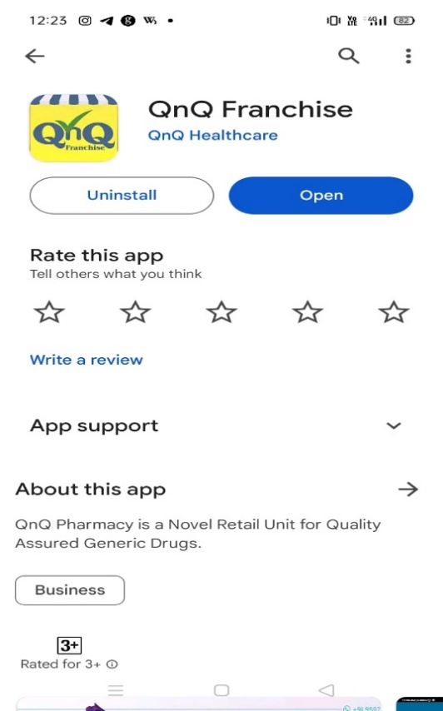Install the app on your device.
4. 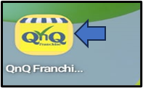Access the app on your mobile or other devices after installation.

**2. SIGN-UP**

* Top of Form

1. Install the app on your device.
2. 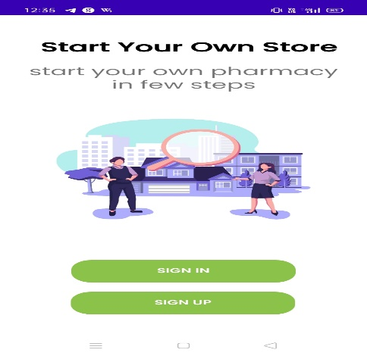Open the app and go to the Sign-up page.
3. 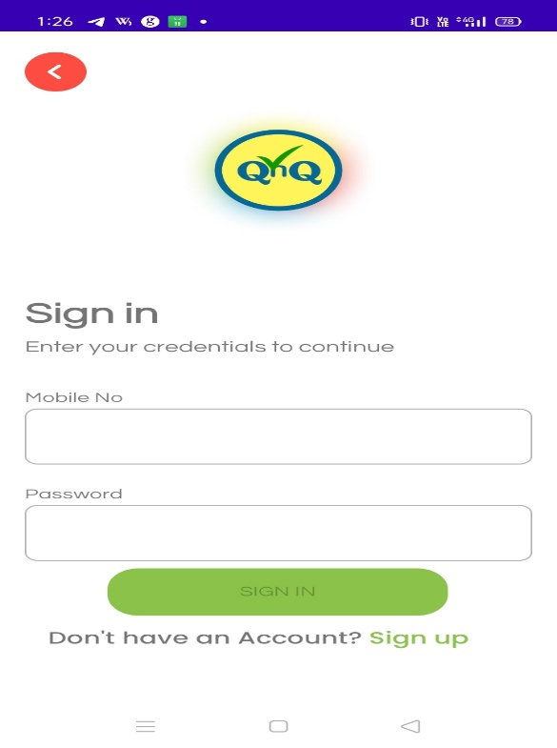If you already have an account, log in using your email and password.
4. If you are a new user, please fill out the account details form below, providing information such as your Name, City, Mobile number, Email, etc.

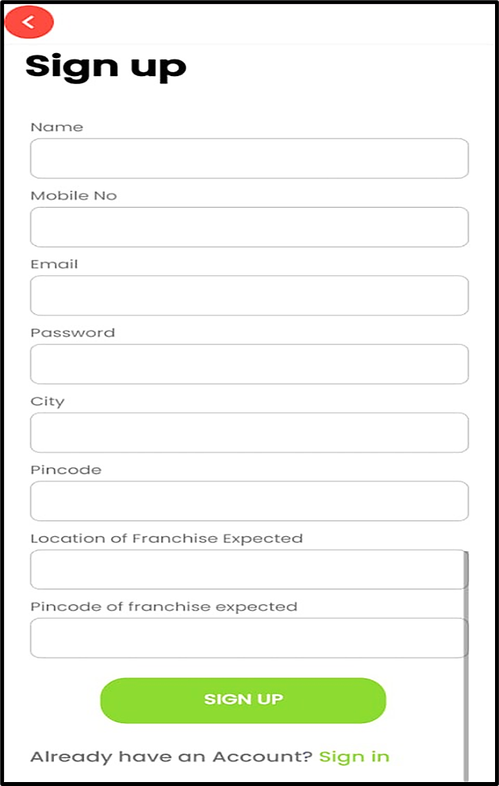

**3. ABOUT US**

1. Successfully register on the platform.
2. Upon completion, users will be welcomed to the 'About Us' section.
3. Explore highlights of our "Vision and Mission" within this section.
4. Find additional information about our company branches.



**4. PROFILE**

1. Navigate to the 'About Us' section.
2. Proceed to the 'Profile' section displayed after 'About Us.'
3. Below 'Profile,' you will find sections for 'Personal Details,' 'Bank Details,' 'Franchise Request Details,' and 'Franchise Images.'

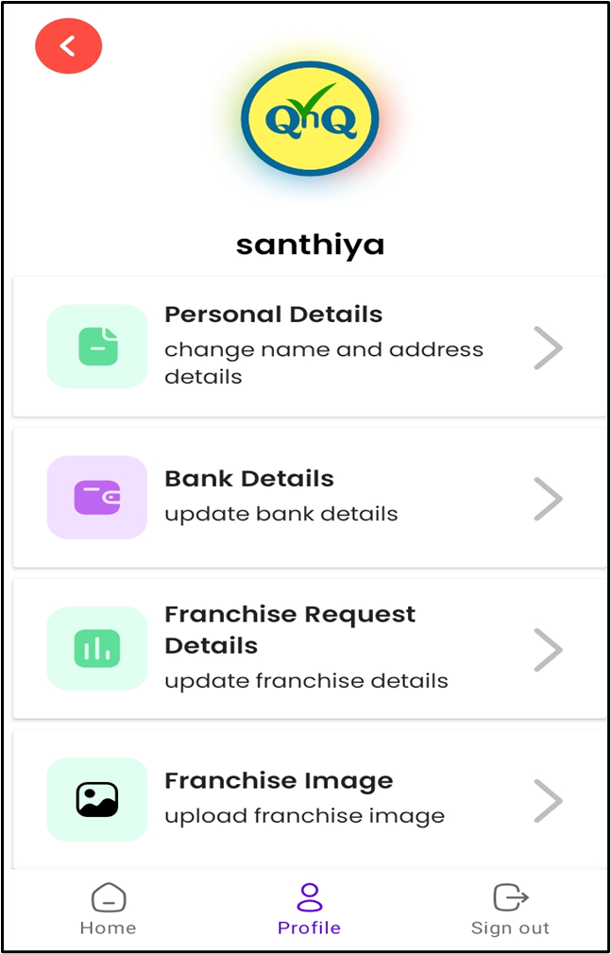

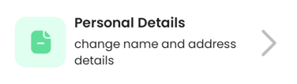**5. PERSONAL DETAILS**

1. To access the 'Personal Details' section above, click on the bar.
2. It will take you to the 'Update Personal Details' enquiry form.
3. Enter the required form details and proceed with the update.

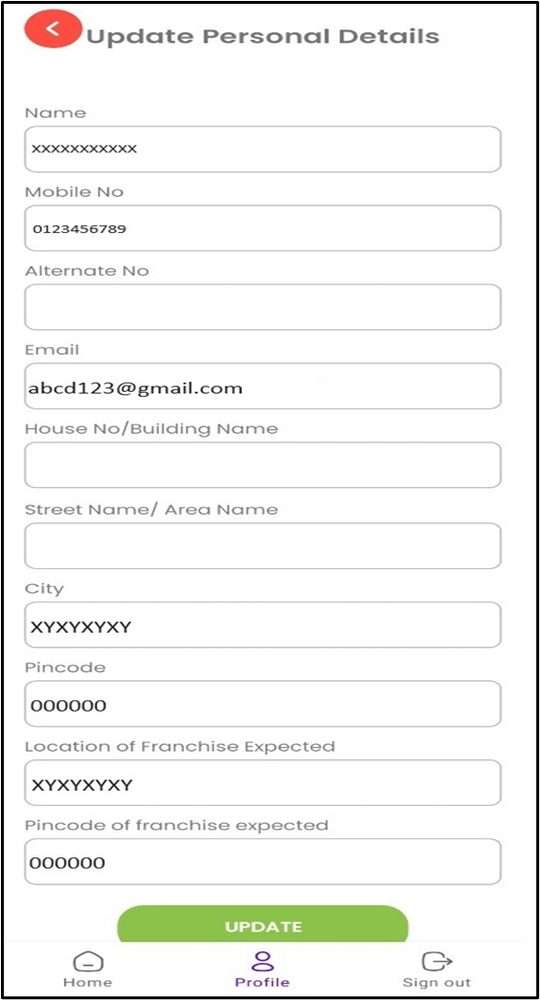

**6. BANK DETAILS**

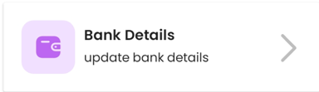

1. To access the 'Bank Details' section above, click on the bar.
2. It will take you to the 'Update Bank Details' form.
3. Enter the necessary details such as account number, PAN number, Aadhaar number, etc., and proceed with the update.

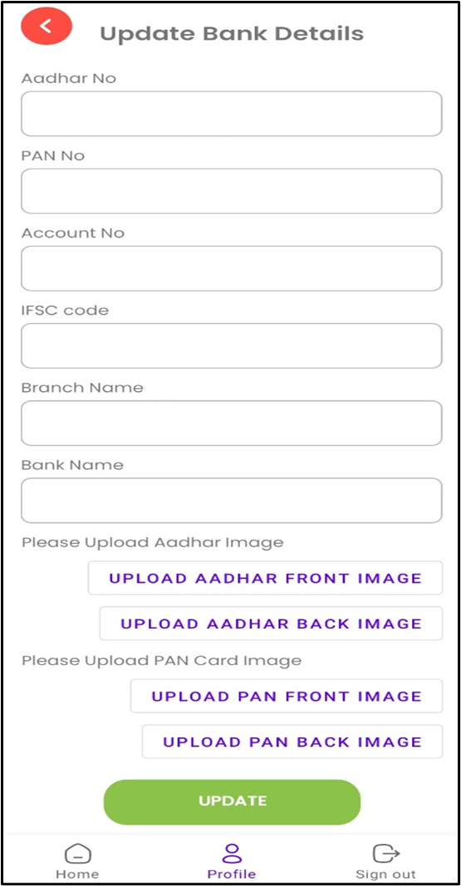

**7. FRANCHISE REQUEST DETAILS**

1. To access the 'Franchise Request Details' section above, click on the bar.
2. It will take you to the 'Update Franchise Details' form.
3. Enter the required information by selecting options such as location identification, carpet area, AC fitting, etc., and proceed with the update.

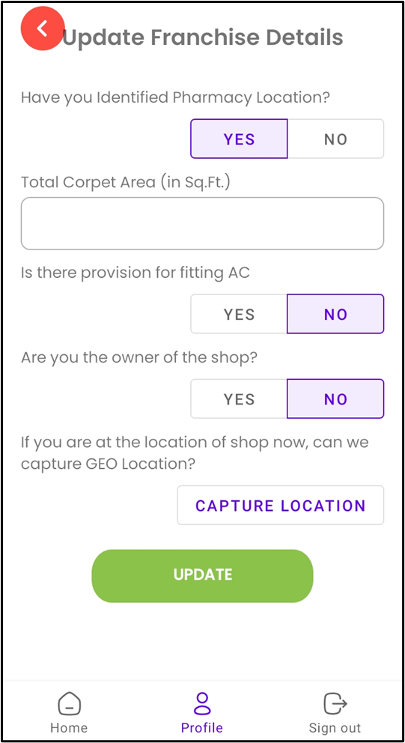

**8. FRANCHISE IMAGES**

1. After completing the above details, go to 'Franchise Images.’
2. To access the 'Franchise Images' section above, click on the bar.
3. It will take you to the 'Update Bank Details' form.
4. 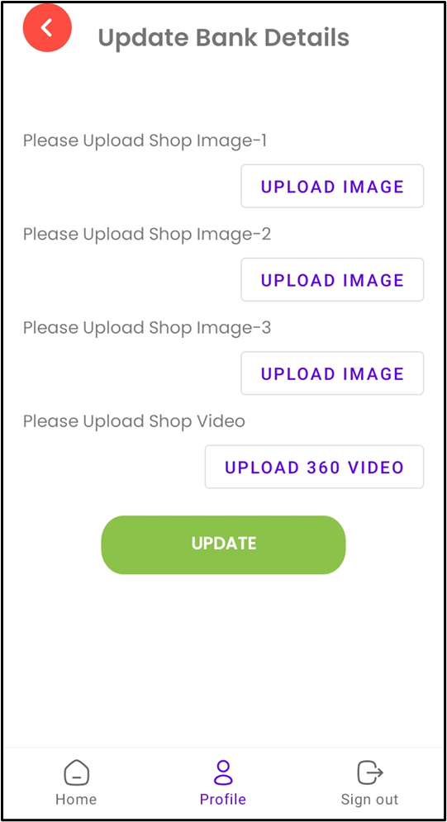Enter and upload the franchise's images and videos, then proceed with the update.

**Successful!**

* Once the above details are fully completed and uploaded, it is the "Franchise Team or Assistant" who will reach out and contact you.